Azure Microsoft Machine Learning Studio

Automobile price prediction project

* In this project, we try to predict the automobile price through linear regression model in azure ML sstudio. Azure machine learning provides rich, consolidated capabilities for model training and deploying. we build the model by drag and drop method of various inbuild functions and automobile price prediction data set which already available in studio.

**Work flow:**

1. Data import
2. Check the data for missing values
3. Preprocess data (missing value imputation, outlier treatment, normalization)
4. mode selection
5. model training
6. model testing
7. model deployment
8. **Data import:**

* Important the raw data set which is in csv format.
* The data is already Pre-available in azure ML classic studio.

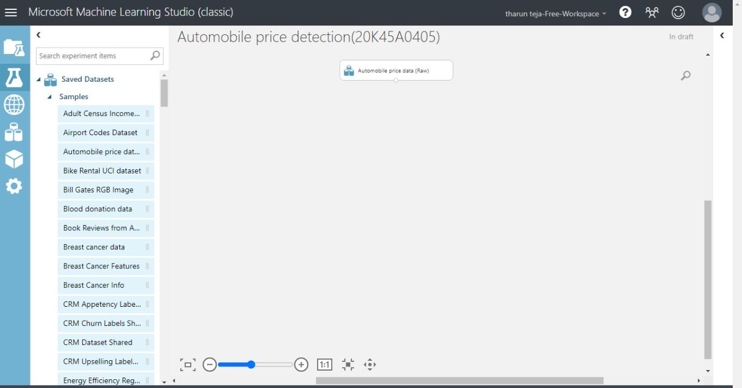

1. **Check the data for the missing values**

* 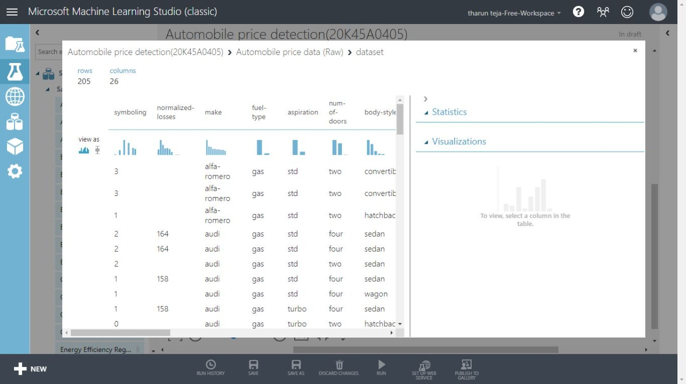In the below we can see that normalized losses column is missing the data.
* We need to check the missing values in the column.

1. **Preprocess the data**

* After cleaning the data of all missing values select all column in data set for splitting process.

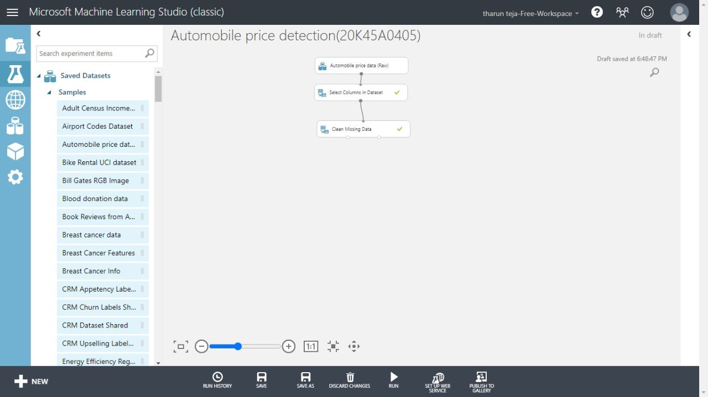

* **There are many missing values in the normalized losses column so we have to exclude it.**

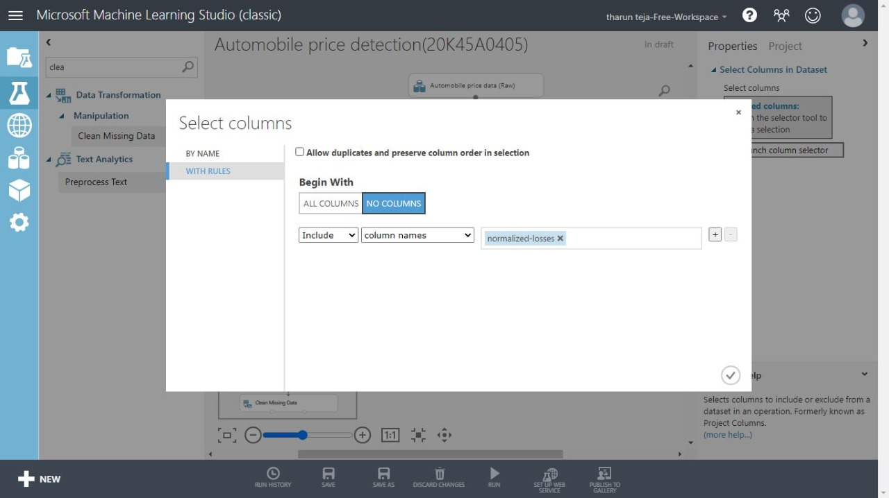

1. **Split the data**

* Use the split data module to randomly divide the input data.

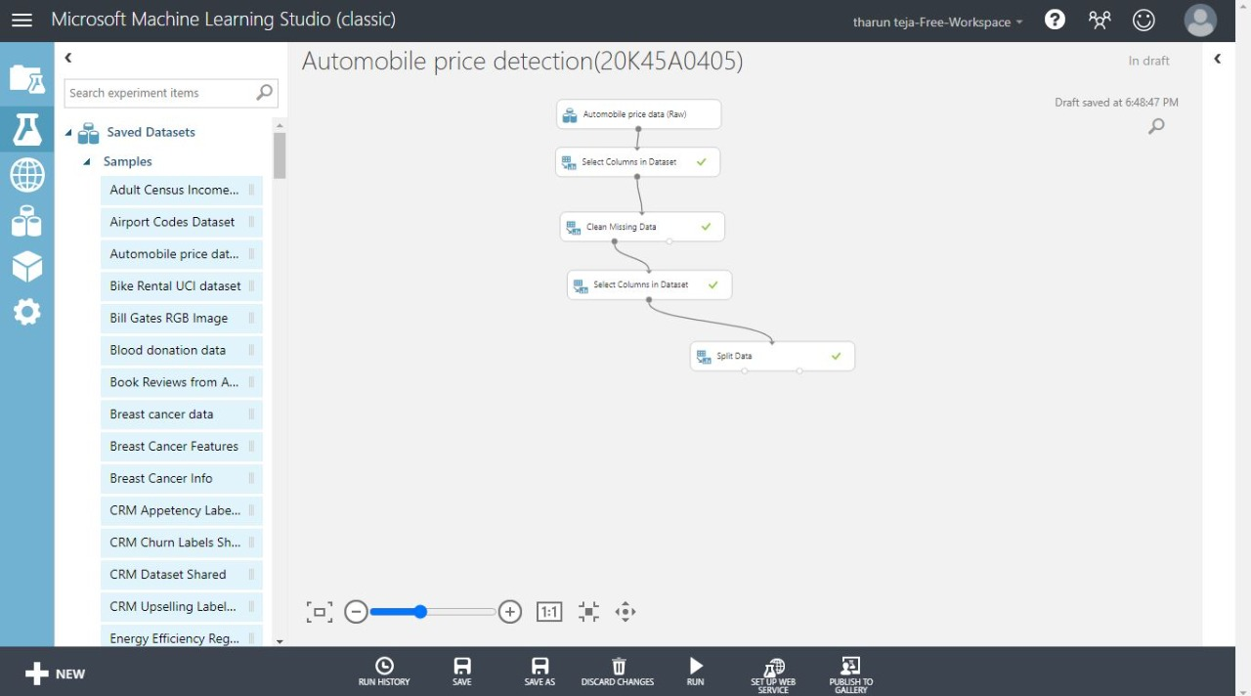

1. **Training Model**

* We are using a linear regression to train the model.

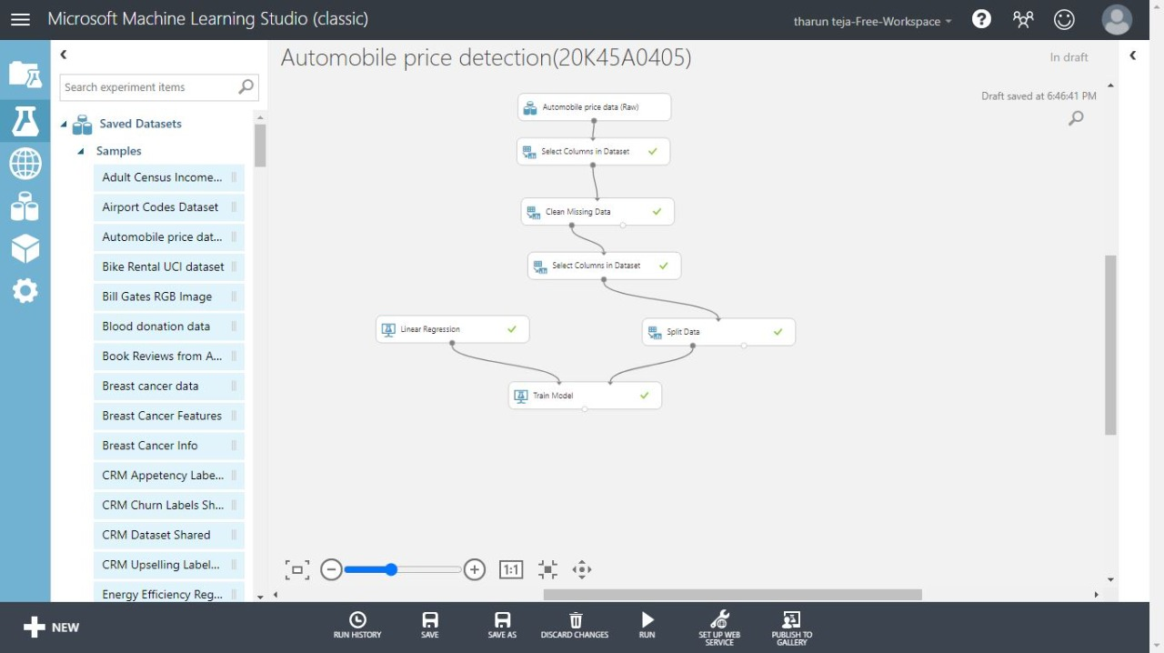

**6. Evaluating the model**

* We test the how the model will work. 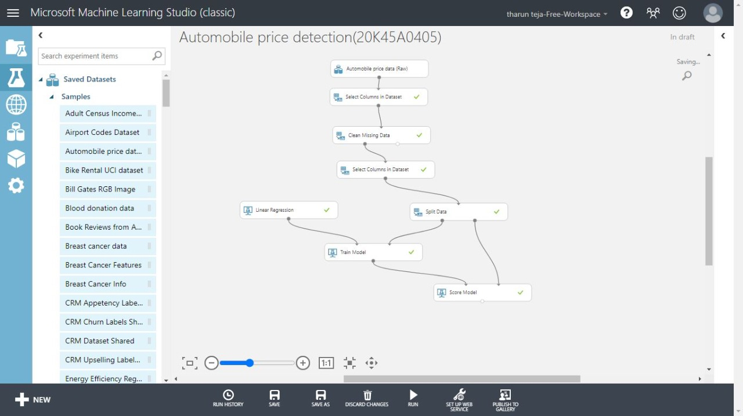

**7.Evaluation Results**

* If we run the model we can the predicted results model of our model.

